

Beautiful Soup Documentation

<https://www.crummy.com/software/BeautifulSoup/bs4/doc/>

parse html and extract data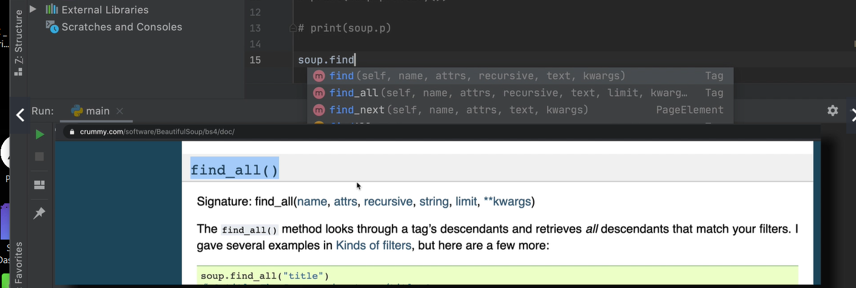

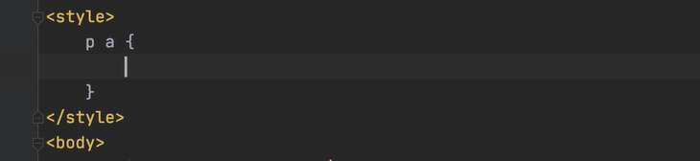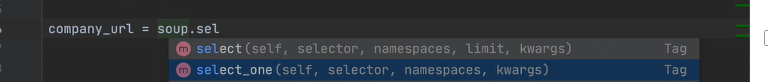

Hacker news

<https://news.ycombinator.com/>

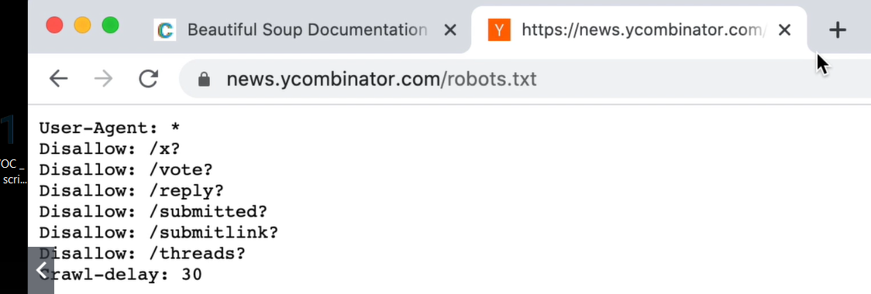

<https://www.empireonline.com/movies/features/best-movies-2/>

**Summary of Methods with Explanation and Timing Results**

There are three different built-in ways to reverse a list. Which method is best depends on whether you need to:

1. Reverse an existing list in-place (altering the original list variable)
   * **Best solution is object.reverse() method**
2. Create an iterator of the reversed list (because you are going to feed it to a for-loop, a generator, etc.)
   * **Best solution is reversed(object) which creates the iterator**
3. Create a copy of the list, just in the reverse order (to preserve the original list)
   * **Best solution is using slices with a -1 step size: object[::-1]**

<https://stackoverflow.com/questions/3940128/how-can-i-reverse-a-list-in-python#:~:text=Method%201%3A%20Reverse%20in%20place%20with%20obj.&text=reverse()%20function.,returns%20the%20reversed%20list%20back>.

For loop

